1. Sure! Let's break these user stories down into actionable tasks and create a product backlog.

### User Story 1: "As a user, I want to log in securely so that I can access my account."

1. Design Login Page: Create the design and layout for the login page.

2. Implement Login Form: Develop the login form with fields for username and password.

3. Set Up Authentication: Integrate backend authentication services (e.g., OAuth, JWT).

4. Encrypt User Passwords: Ensure passwords are stored securely using encryption.

5. Validate User Input: Add validation for user inputs (e.g., check for empty fields, valid email format).

6. Create Login API Endpoint: Develop the API endpoint for user login.

7. Handle Login Errors: Implement error handling for invalid login attempts.

8. Create Sessions/Cookies: Manage user sessions or cookies to maintain login state.

9. Test Login Functionality: Conduct testing to ensure login works securely and smoothly.

10. Implement Logout Functionality: Ensure users can log out securely.

### User Story 2: "As a user, I want to search for products by category to find items easily."

1. Design Search Interface: Create the design and layout for the search interface.

2. Implement Category Filter: Develop the category filter dropdown or sidebar.

3. Create Search API Endpoint: Develop the API endpoint for product search.

4. Fetch Product Data: Retrieve product data from the database based on search criteria.

5. Display Search Results: Show search results on the user interface.

6. Add Pagination: Implement pagination for search results if necessary.

7. Sort Products: Allow users to sort search results by different criteria (e.g., price, popularity).

8. Add Product Categories: Ensure all products are categorized accurately.

9. Test Search Functionality: Conduct testing to ensure search and category filters work correctly.

### Product Backlog Items (PBIs)

1. Design Login Page

2. Implement Login Form

3. Set Up Authentication

4. Encrypt User Passwords

5. Validate User Input

6. Create Login API Endpoint

7. Handle Login Errors

8. Create Sessions/Cookies

9. Test Login Functionality

10. Implement Logout Functionality

11. Design Search Interface

12. Implement Category Filter

13. Create Search API Endpoint

14. Fetch Product Data

15. Display Search Results

16. Add Pagination

17. Sort Products

18. Add Product Categories

19. Test Search Functionality

Feel free to add more tasks or adjust priorities as needed! Would you like to explore any of these tasks in more detail?

ii)During a Sprint Planning meeting, the development team, along with the Product Owner, can prioritize user stories by considering both the value to the customer and the technical feasibility of each task. Here's how they can approach this:

### 1. Value to the Customer

Assessing how each user story impacts the customer experience is critical:

- User Story: Log in securely:

- Value: Extremely high. Without secure login, users cannot access the application, making this a fundamental feature.

- Reasoning: This feature is essential for user access and security, establishing trust and credibility.

- User Story: Search for products by category:

- Value: High. Enhances user experience by allowing users to find items easily.

- Reasoning: Improves usability and helps users find products efficiently, which can lead to higher user satisfaction and increased sales.

### 2. Technical Feasibility

Evaluating the technical complexity and effort required to implement each user story:

- User Story: Log in securely:

- Complexity: Moderate. Involves designing the login page, setting up authentication, encrypting passwords, and handling errors.

- Tasks:

- Design login page

- Implement login form

- Set up authentication

- Encrypt user passwords

- Handle login errors

- User Story: Search for products by category:

- Complexity: Also moderate. Involves designing the search interface, developing category filters, creating the search API, and displaying results.

- Tasks:

- Design search interface

- Implement category filter

- Create search API

- Display search results

### Prioritization Plan

1. Immediate Sprint:

- User Story: Log in securely

- This story should be prioritized first due to its fundamental nature and high value to the customer.

- Start with the most critical tasks: designing the login page, implementing the login form, setting up authentication, and encrypting passwords.

2. Subsequent Sprint:

- User Story: Search for products by category

- Once the login functionality is in place, move on to implementing the search functionality.

- Begin with designing the search interface and implementing the category filter.

### Additional Considerations

- Feedback Loop: After implementing each user story, collect customer feedback to ensure the features meet their needs and make any necessary adjustments.

- Refinement Sessions: Regularly refine the Product Backlog to keep it up-to-date and prioritize based on the evolving requirements and feedback.

### Prioritization during Sprint Planning

- Discuss the importance and impact of each user story with the team.

- Evaluate the effort estimates provided by the development team.

- Make informed decisions based on value and feasibility, ensuring that the most critical features are delivered first.

By following this structured approach, the development team can effectively prioritize user stories during the Sprint Planning meeting, ensuring that they deliver maximum value to the customer while managing technical complexities efficiently.

Iii)

A Scrum board is a visual tool used to track the progress of tasks in a Sprint. It helps the team see the status of different tasks at a glance. Here's how you might set up a Scrum board to track the user stories for the e-commerce application:

### Scrum Board

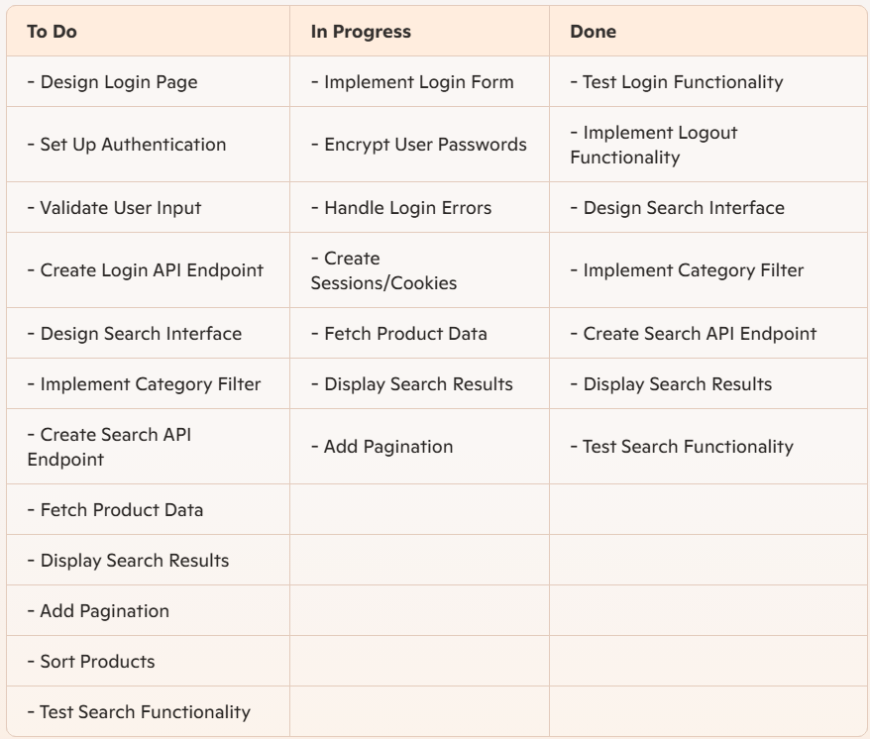

### Explanation

1. **To Do**: Tasks that have been identified and are ready to be started.
2. **In Progress**: Tasks that are currently being worked on by the development team.
3. **Done**: Tasks that have been completed.

By moving tasks from the "To Do" column to "In Progress" and finally to the "Done" column, the team can track the progress of each user story. This visual representation helps ensure that the team remains focused and aligned with the sprint goals.

Would you like more details on any specific task or aspect of using a Scrum board?

Let's explore how the Spiral, Agile, and Extreme Programming (XP) methodologies address risk management and adaptability, and determine which is most suitable for a high-risk project with evolving requirements.

### Spiral Model

#### Risk Management:

- Iterative Approach: The Spiral model combines iterative development with systematic, structured risk analysis.

- Risk Analysis: Each phase begins with a thorough risk assessment and mitigation strategy. This continuous risk assessment allows the team to identify and address potential issues early.

- Prototyping: Early creation of prototypes to understand requirements better and to validate design decisions.

#### Adaptability:

- Incremental Development: Allows for iterative refinement of requirements and design through each spiral.

- Client Feedback: Continuous client feedback is incorporated at each iteration, making it adaptable to changes.

### Agile Methodology

#### Risk Management:

- Incremental Delivery: Focuses on delivering small, workable segments of the product in short iterations.

- Frequent Testing: Regular testing within iterations helps identify and address risks early.

- Collaboration: Encourages constant communication and collaboration among team members and stakeholders, which helps identify risks quickly.

#### Adaptability:

- Flexibility: Agile’s iterative nature allows for easy adjustment to changing requirements.

- Customer Involvement: Active involvement of the customer throughout the development process ensures that changes are promptly addressed.

### Extreme Programming (XP)

#### Risk Management:

- Frequent Releases: XP emphasizes frequent releases of small increments, which reduces the risk associated with large, late changes.

- Continuous Integration: Regularly integrating and testing code helps identify issues early.

- Pair Programming: Encourages code reviews and shared knowledge, reducing the risk of individual points of failure.

#### Adaptability:

- User Stories: Uses user stories to define requirements, which can be easily modified as the project evolves.

- Simplicity: Promotes simplicity in design and code, making it easier to adapt to changes.

- Customer Feedback: Frequent feedback from the customer ensures that the product evolves according to their needs.

### Recommendation

Given the high risks and evolving requirements, the Agile methodology is likely the most suitable for this project. Here’s why:

- Iterative Process: Agile’s short, iterative cycles allow for regular reassessment of priorities and risks, making it easier to adapt to changes.

- Customer Collaboration: Continuous engagement with the client helps ensure that the product evolves in line with their needs, reducing the risk of delivering a product that doesn't meet expectations.

- Flexibility and Responsiveness: Agile’s flexibility in accommodating changes and its focus on delivering value quickly make it well-suited for high-risk, innovative projects.

By adopting Agile, the development team can manage risks effectively while remaining adaptable to the client’s evolving needs, ensuring the software evolves in a manageable and cost-effective way.

Let's compare and contrast the Waterfall, Agile, Extreme Programming (XP), and Spiral development models, and analyze which methodology best suits Project A and Project B.

### Waterfall Model

#### Characteristics:

- Linear and Sequential: Each phase must be completed before the next begins.

- Well-defined Requirements: Suitable for projects with clear and fixed requirements.

- Predictability: High; each phase has specific deliverables and a review process.

#### Pros:

- Structured Approach: Easy to manage and track progress.

- Documentation: Extensive documentation provides clarity and reference.

#### Cons:

- Inflexibility: Difficult to accommodate changes once a phase is completed.

- Late Testing: Testing is performed only at the end, potentially missing early detection of issues.

### Agile Methodology

#### Characteristics:

- Iterative and Incremental: Focuses on delivering small, workable segments in short iterations.

- Customer Collaboration: Continuous involvement and feedback from customers.

- Flexibility: Adaptable to changing requirements.

#### Pros:

- Adaptability: Easy to accommodate changes based on customer feedback.

- Early Testing: Continuous testing throughout the development process.

#### Cons:

- Less Predictability: Iterative nature might lead to less predictability in project timelines.

- Requires Discipline: Needs a high level of team collaboration and discipline.

### Extreme Programming (XP)

#### Characteristics:

- Frequent Releases: Small, frequent releases of the software.

- Continuous Integration: Regular integration and testing of code.

- Customer Feedback: Constant feedback from customers.

#### Pros:

- High Quality: Continuous testing and code review improve code quality.

- Responsiveness: Quick response to changing requirements and customer feedback.

#### Cons:

- Intensive Collaboration: Requires constant communication and collaboration, which can be demanding.

- Complex Projects: May not suit very large, complex projects with less defined requirements.

### Spiral Model

#### Characteristics:

- Iterative: Combines iterative development with systematic risk analysis.

- Risk Management: Emphasizes identifying and mitigating risks early.

- Prototyping: Early creation of prototypes to validate design decisions.

#### Pros:

- Risk Handling: Focuses on early identification and mitigation of risks.

- Flexibility: Allows for changes based on continuous feedback and prototyping.

#### Cons:

- Complexity: Can be complex to implement due to the emphasis on risk analysis.

- Resource Intensive: Requires significant resources for continuous prototyping and risk analysis.

### Methodology Suitability for Projects

#### Project A: Well-defined Requirements and Strict Deadline

- Most Suitable Methodology: Waterfall

- Predictability: The linear and sequential approach ensures that the project stays on track with well-defined deliverables and timelines.

- Structured Approach: The structured nature of Waterfall makes it easier to manage and track progress, which is critical for meeting strict deadlines.

- Clear Documentation: Extensive documentation helps ensure that all requirements are met without deviation.

#### Project B: Evolving Requirements with Uncertain Timeline and Continuous Customer Feedback

- Most Suitable Methodology: Agile

- Adaptability: Agile's iterative approach allows for easy accommodation of evolving requirements and continuous customer feedback.

- Customer Collaboration: Regular involvement of the customer ensures that the product evolves according to their needs and preferences.

- Flexibility: Agile's flexibility makes it easier to manage changes and uncertainty in the project timeline.

### Conclusion

- Project A benefits from the structured and predictable nature of the Waterfall model, ensuring that well-defined requirements are met within a strict deadline.

- Project B thrives on the adaptability, customer collaboration, and iterative nature of the Agile methodology, making it suitable for projects with evolving requirements and continuous feedback.

By selecting the appropriate methodology for each project, the company can effectively address the specific needs of both projects, ensuring successful outcomes.

Software engineering ethics encompasses a set of principles and guidelines that help professionals make ethically sound decisions in their work. These principles address issues of professional responsibility and ensure that software engineers act in ways that promote trust, fairness, and integrity. Let's explore the key principles of software engineering ethics and how the ACM/IEEE Code of Ethics guides ethical decision-making:

### Principles of Software Engineering Ethics

1. Public Interest:

- Software engineers should act consistently with the public interest. They must prioritize the well-being and safety of the public, ensuring that their work does not harm individuals or society.

2. Client and Employer Responsibility:

- Software engineers must act in the best interest of their clients and employers, provided that their actions are consistent with the public interest. This includes maintaining confidentiality and avoiding conflicts of interest.

3. Product Quality:

- Engineers should strive to produce high-quality software that meets the needs of users. This involves adhering to best practices, standards, and continuous improvement.

4. Professional Competence:

- Software engineers must maintain and improve their technical competence through continuous learning and professional development. They should only undertake tasks for which they are qualified.

5. Fairness and Non-Discrimination:

- Engineers should treat all individuals fairly and avoid discrimination based on race, gender, age, disability, or other factors. They should promote diversity and inclusiveness in their profession.

6. Integrity and Honesty:

- Software engineers should be honest and transparent in their professional dealings. They must avoid deceptive practices and accurately represent their work and its limitations.

7. Privacy and Confidentiality:

- Engineers must respect the privacy of individuals and the confidentiality of sensitive information. They should implement robust security measures to protect data.

### ACM/IEEE Code of Ethics

The ACM/IEEE Code of Ethics provides a framework to guide ethical decision-making for software engineers. Here are some key components:

1. Public Interest:

- Principle 1.01: Contribute to society and human well-being.

- Principle 1.02: Avoid harm to others.

2. Client and Employer Responsibility:

- Principle 2.03: Be honest and trustworthy.

- Principle 2.05: Honor contracts, agreements, and responsibilities.

3. Product Quality:

- Principle 3.01: Strive for high-quality, maintainable, and dependable software.

- Principle 3.02: Ensure that the software meets the needs of users.

4. Professional Competence:

- Principle 4.01: Improve and maintain professional competence.

- Principle 4.03: Know and respect existing laws and standards.

5. Fairness and Non-Discrimination:

- Principle 5.01: Treat all individuals fairly and with respect.

- Principle 5.02: Encourage diversity and inclusiveness.

6. Integrity and Honesty:

- Principle 6.01: Be honest about the limitations and potential risks of the software.

- Principle 6.03: Avoid deceptive practices.

7. Privacy and Confidentiality:

- Principle 7.01: Respect the privacy of individuals.

- Principle 7.02: Protect confidential and proprietary information.

### Ethical Decision-Making in Practice

The ACM/IEEE Code of Ethics provides practical guidelines to help software engineers navigate complex ethical dilemmas. For example:

- Scenario: A software engineer discovers a security vulnerability in a product close to release.

- Ethical Response: The engineer should report the vulnerability to the appropriate parties, even if it delays the release, to avoid potential harm to users (Principle 1.02: Avoid harm to others).

- Scenario: A client requests the engineer to implement a feature that may compromise user privacy.

- Ethical Response: The engineer should discuss the potential risks with the client and advocate for an alternative solution that respects user privacy (Principle 7.01: Respect privacy).

By adhering to the principles of software engineering ethics and the ACM/IEEE Code of Ethics, software engineers can make informed, responsible decisions that uphold the integrity of their profession and contribute to the greater good.

Sure! Let's identify and explain the functional and non-functional requirements for an Airport Reservation System:

### Functional Requirements

1. User Authentication:

- Description: The system must allow users to securely log in and register.

- Contribution: Ensures that only authorized users can access their accounts, contributing to security and personalized user experience.

2. Flight Search:

- Description: Users should be able to search for available flights based on criteria such as destination, date, and class.

- Contribution: Enhances usability by providing users with an easy way to find relevant flights, improving the user experience.

3. Booking Management:

- Description: Users must be able to book, modify, and cancel flight reservations.

- Contribution: Facilitates user control over their reservations, ensuring flexibility and convenience, which boosts user satisfaction.

4. Payment Processing:

- Description: The system should support secure payment processing for bookings.

- Contribution: Ensures transactions are completed securely and efficiently, which is vital for trust and financial security.

5. Notification System:

- Description: Users should receive notifications for booking confirmations, cancellations, and flight updates.

- Contribution: Keeps users informed and up-to-date, improving their overall experience and trust in the system.

### Non-Functional Requirements

1. Performance:

- Description: The system should respond to user actions within 2 seconds.

- Contribution: Ensures fast and efficient performance, leading to a smoother user experience and higher satisfaction.

2. Scalability:

- Description: The system must be able to handle increasing numbers of users and transactions without performance degradation.

- Contribution: Ensures the system can grow with the user base, maintaining performance and reliability even as demand increases.

3. Usability:

- Description: The interface should be intuitive and user-friendly, requiring minimal training for users.

- Contribution: Enhances the ease of use, making the system accessible to a broader audience and reducing user frustration.

4. Security:

- Description: The system should implement strong encryption and secure authentication mechanisms.

- Contribution: Protects user data and transactions from unauthorized access and breaches, ensuring user trust and compliance with regulations.

5. Maintainability:

- Description: The system should be designed in a modular way, making it easy to update and maintain.

- Contribution: Facilitates easier updates and bug fixes, ensuring the system remains up-to-date and reliable over time.

### How Each Requirement Contributes

#### Performance

- Performance Requirement: Fast response times prevent user frustration, making the system more attractive and competitive.

- Functional Contribution: Quick flight searches and payment processing enhance the overall user experience.

#### Usability

- Usability Requirement: An intuitive interface ensures that users can navigate the system easily, improving satisfaction and reducing the need for extensive training.

- Functional Contribution: Simplified booking management and flight search functionalities make the system more accessible.

#### Security

- Security Requirement: Strong security measures protect sensitive user information, such as payment details and personal data.

- Functional Contribution: Secure user authentication and payment processing build trust and ensure regulatory compliance.

#### Scalability

- Scalability Requirement: The system's ability to handle growing numbers of users and transactions without performance issues ensures reliability.

- Functional Contribution: Efficient booking management and search functionalities remain effective even as the user base grows.

#### Maintainability

- Maintainability Requirement: A modular design allows for easier updates and maintenance, ensuring the system stays functional and secure over time.

- Functional Contribution: Regular updates to features such as notifications and booking management improve the user experience without disrupting service.

By addressing both functional and non-functional requirements, the Airport Reservation System can achieve high performance, usability, and security, ensuring a positive and secure user experience.

Let's break down the V-model of testing phases in a plan-driven software process.

**The V-Model: A Visual Representation**

The V-model is a visual representation of the software development life-cycle (SDLC) that emphasizes the relationship between development and testing activities. It's shaped like a V, with development activities on the left side and testing activities on the right.

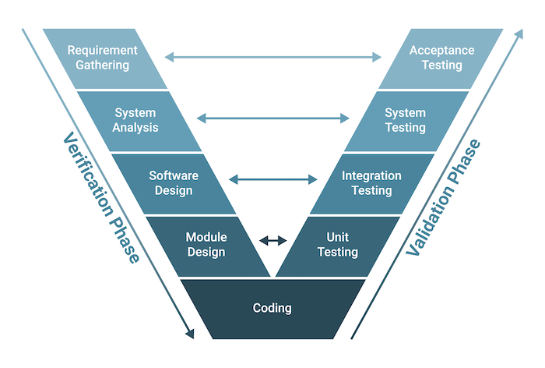

**Development Activities (Left Side of the V)**

* **Business Requirements Analysis:** This is the initial stage where you define the high-level needs and goals of the software from a business perspective.
* **System Design:** Here, you translate the business requirements into a high-level system architecture, outlining the components, modules, and their interactions.
* **Architectural Design:** This phase focuses on the technical aspects, detailing the hardware, software, and communication infrastructure of the system.
* **Module Design:** You break down the system into smaller, manageable modules, specifying their functionality and interfaces.
* **Coding:** This is where the actual code is written, implementing the design specifications.

**Testing Activities (Right Side of the V)**

* **Unit Testing:** This involves testing individual modules or components in isolation to ensure they function correctly.
* **Integration Testing:** You combine the tested modules and verify that they work together seamlessly.
* **System Testing:** The entire system is tested as a whole to ensure it meets the specified requirements and performs as expected.
* **Acceptance Testing:** This is the final stage where the software is tested by the end-users or stakeholders to ensure it meets their needs and expectations.

**Relationships Between Development and Testing**

The V-model highlights the direct relationship between each development phase and its corresponding testing phase. This ensures that testing is not an afterthought but an integral part of the development process.

* **Business Requirements Analysis** is linked to **Acceptance Testing**, ensuring that the software meets the business needs.
* **System Design** is linked to **System Testing**, validating that the system meets the overall design specifications.
* **Architectural Design** is linked to **Integration Testing**, verifying that the different components work together correctly.
* **Module Design** is linked to **Unit Testing**, ensuring that each module functions as intended.

**Benefits of the V-Model**

* **Early Defect Detection:** Testing is integrated throughout the development process, allowing for early detection and resolution of defects.
* **Improved Quality:** The emphasis on testing leads to higher quality software that meets user needs and expectations.
* **Reduced Costs:** Early defect detection minimizes the cost of fixing defects later in the development cycle.
* **Clearer Understanding:** The V-model provides a clear understanding of the development and testing process, facilitating communication and collaboration among team members.

**Limitations of the V-Model**

* **Rigidity:** The V-model can be inflexible, making it challenging to accommodate changes or deviations from the plan.
* **Limited User Involvement:** User involvement is primarily limited to the acceptance testing phase, which may not be sufficient to gather feedback and ensure user satisfaction throughout the development process.

**Conclusion**

The V-model is a valuable tool for plan-driven software development, emphasizing the importance of testing and its relationship to development activities. It promotes early defect detection, improves software quality, and reduces costs. However, it's essential to consider its limitations and adapt it as needed to fit the specific needs of the project.

Prototype development in software engineering is an iterative approach that focuses on creating preliminary versions of a software application to better understand user requirements and refine functionality before final development. Here's a breakdown of the key stages involved in creating a prototype:

### Key Stages of Prototype Development:

1. Requirement Gathering and Analysis:

- Understanding Needs: Collaborate with stakeholders to identify and gather initial requirements.

- Define Objectives: Clearly outline the objectives and goals of the prototype.

2. Quick Design:

- Initial Design: Develop a basic and quick design layout based on gathered requirements.

- Focus on Key Features: Emphasize core functionalities without going into detailed design.

3. Prototype Development:

- Create Prototype: Build the first version of the prototype using tools and techniques suitable for rapid development.

- Simulate User Interface: Develop a simulated or mock user interface to visualize user interactions.

4. User Evaluation:

- User Feedback: Present the prototype to users and stakeholders for feedback.

- Collect Insights: Gather insights on the usability, functionality, and overall user experience.

5. Refinement and Iteration:

- Incorporate Feedback: Modify and improve the prototype based on the feedback received.

- Repeat the Process: Iterate through the design, development, and evaluation stages as needed.

6. Finalization:

- Freeze the Design: Finalize the design and requirements based on the refined prototype.

- Transition to Development: Move to the detailed design and full-scale development phase.

### How Prototyping Helps in Refining Software Requirements:

- Early Detection of Issues: Allows identification and resolution of potential issues early in the development cycle.

- Clearer Requirements: Helps in eliciting clearer and more accurate requirements by providing a visual representation.

- User Involvement: Engages users and stakeholders in the development process, ensuring their needs and expectations are met.

- Improved Communication: Facilitates better communication and understanding between developers and stakeholders through tangible models.

### Benefits of Using the Prototyping Model:

- User Feedback:

- Active Participation: Encourages continuous user involvement and feedback.

- Enhanced Satisfaction: Increases user satisfaction by aligning the product with user expectations.

- Risk Reduction:

- Minimize Risks: Helps in identifying and mitigating risks early in the project.

- Validation: Validates assumptions and requirements before committing to full-scale development.

- Iterative Development:

- Continuous Improvement: Supports iterative refinement and improvement of the software.

- Flexibility: Offers flexibility to adapt to changes in requirements and feedback.

In essence, the prototyping model is highly effective for developing user-centric applications, ensuring that the final product aligns closely with user needs and expectations while minimizing risks and enabling iterative progress.

Is there a specific project you're working on that involves prototyping? I can help with some targeted advice if you'd like.

### ****Process Improvement Cycle in Software Engineering****

The process improvement cycle in software engineering is an iterative approach used to enhance software quality, reduce costs, and accelerate development. It consists of three key stages:

1. **Measure**: Collect data on the software process and product by measuring attributes such as efficiency, defects, and time taken. This serves as a baseline for improvement.
2. **Analyze**: Assess the collected data to identify weaknesses, bottlenecks, or inefficiencies in the process. Process models may be developed for better understanding.
3. **Change**: Implement improvements based on the analysis to address identified weaknesses. After changes are made, the cycle resumes with measurement to assess effectiveness.

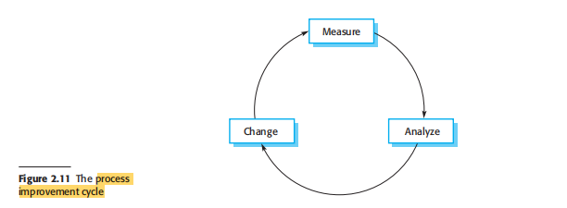

### ****Commonly Used Process Metrics****

Process metrics help in monitoring and improving software processes. Some key metrics include:

* **Defect Density**: Number of defects per unit size (e.g., per KLOC - thousand lines of code). Helps in assessing software quality.
* **Cycle Time**: Time taken to complete one iteration of development. Useful in tracking efficiency and speed.
* **Mean Time to Failure (MTTF)**: Average time between software failures. Indicates reliability.
* **Effort Variance**: Difference between estimated and actual effort required. Helps in improving estimation accuracy.
* **Customer Satisfaction**: Measured through surveys or feedback. Reflects process effectiveness.

By continuously measuring and refining processes using these metrics, software engineering teams can improve product quality, optimize resource utilization, and enhance customer satisfaction.

The Software Engineering Institute Capability Maturity Model (SEI CMM) is a framework designed to improve and assess the maturity of software development processes within an organization. It provides a structured approach to process improvement by defining five distinct levels of capability and maturity. Each level represents a step towards achieving a more efficient, predictable, and high-quality software development process.

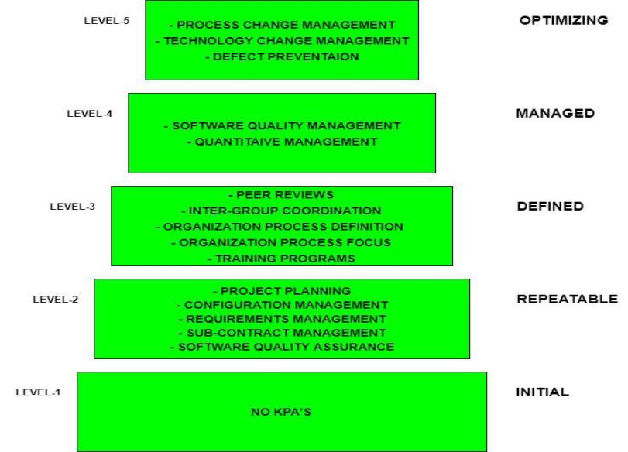

### The Five Levels of SEI CMM:

1. Level 1: Initial (Chaotic)

- Characteristics: Processes are ad hoc, unstructured, and reactive. Success depends on individual efforts rather than a defined process.

- Challenges: Unpredictable outcomes, high risk, and difficulty in repeating success.

- Contribution: Recognizes the need for process improvement and sets the stage for moving to higher levels.

2. Level 2: Repeatable

- Characteristics: Basic project management processes are established. Projects can be repeated with similar outcomes.

- Focus: Requirements management, project planning, project tracking, quality assurance, and configuration management.

- Contribution: Establishes a foundation for process discipline, leading to more predictable project outcomes and reduced risk.

3. Level 3: Defined

- Characteristics: Processes are well-documented, standardized, and integrated into the organization's standard process.

- Focus: Process definition, training programs, integrated project management, and peer reviews.

- Contribution: Encourages consistency across projects, enhances communication, and allows for more effective process improvement efforts.

4. Level 4: Managed

- Characteristics: Processes are quantitatively measured and controlled. Performance is predictable and based on data-driven decision-making.

- Focus: Process measurement, quality management, and quantitative project management.

- Contribution: Provides a deeper understanding of process performance, enables proactive management, and facilitates continuous improvement based on metrics.

5. Level 5: Optimizing

- Characteristics: Focus on continuous process improvement through feedback loops, innovation, and adoption of best practices.

- Focus: Process innovation, defect prevention, and continuous process optimization.

- Contribution: Ensures sustained process improvement, fosters a culture of innovation, and drives the organization towards excellence.

### How Each Level Contributes to Improving Software Development and Organizational Performance:

- Level 1 to Level 2: Moving from an initial to a repeatable level helps in establishing basic project management practices, leading to more predictable outcomes and a reduction in project risks.

- Level 2 to Level 3: Defining and standardizing processes across the organization ensures consistency, improves communication, and provides a solid foundation for further process improvements.

- Level 3 to Level 4: Introducing quantitative management allows for data-driven decision-making, enhancing process control, and enabling proactive management of projects.

- Level 4 to Level 5: Continuous process improvement fosters innovation, encourages the adoption of best practices, and drives the organization towards achieving higher levels of performance and quality.

By progressing through these levels, organizations can systematically improve their software development processes, leading to higher quality products, increased customer satisfaction, and better overall organizational performance.

Would you like more detailed information on any specific level or how to implement SEI CMM in your organization?

Agile software development methods emphasize flexibility, collaboration, and customer-centricity. Here are the core principles:

### Core Principles of Agile Software Development:

1. Individuals and Interactions Over Processes and Tools:

- Focus: Prioritize effective communication and collaboration among team members.

- Application: Encourages team autonomy and a culture of mutual respect.

2. Working Software Over Comprehensive Documentation:

- Focus: Deliver functional software frequently, ensuring it meets user needs.

- Application: Emphasizes the importance of delivering value early and continuously.

3. Customer Collaboration Over Contract Negotiation:

- Focus: Involve customers and stakeholders throughout the development process.

- Application: Facilitates better understanding of requirements and more accurate feedback.

4. Responding to Change Over Following a Plan:

- Focus: Adapt to changes in requirements and market conditions.

- Application: Supports iterative development and continuous improvement.

5. Sustainable Development:

- Focus: Maintain a constant pace of development without overburdening the team.

- Application: Promotes a healthy work environment and long-term productivity.

6. Technical Excellence and Good Design:

- Focus: Invest in high-quality code and design to facilitate change.

- Application: Ensures maintainability and scalability of the software.

7. Simplicity:

- Focus: Maximize the amount of work not done by focusing on essential features.

- Application: Avoids over-engineering and unnecessary complexity.

8. Self-Organizing Teams:

- Focus: Empower teams to make decisions and manage their work.

- Application: Encourages innovation and accountability.

9. Regular Reflection and Adaptation:

- Focus: Continuously review and improve processes.

- Application: Conduct retrospectives and adjust practices for better outcomes.

### Application in Different Software Development Environments:

1. Small Startups:

- Application: Agile's flexibility and emphasis on collaboration align well with the dynamic and fast-paced nature of startups.

- Benefits: Rapid prototyping, quick iterations, and close customer engagement.

- Challenges: Limited resources may strain the ability to maintain sustainable development practices.

2. Large Enterprises:

- Application: Agile can be scaled using frameworks like SAFe (Scaled Agile Framework) to manage multiple teams and projects.

- Benefits: Improved responsiveness to market changes, enhanced cross-functional collaboration.

- Challenges: Resistance to change, integrating agile practices with existing processes.

3. Distributed Teams:

- Application: Use of collaborative tools (e.g., video conferencing, project management software) to facilitate communication and coordination.

- Benefits: Flexibility in work location, diverse perspectives.

- Challenges: Time zone differences, ensuring effective communication.

### Benefits of Using Agile Methods:

- Enhanced Customer Satisfaction:

- How: Frequent delivery of valuable software and continuous stakeholder involvement.

- Why: Aligns product development with customer needs and expectations.

- Improved Quality:

- How: Continuous testing, integration, and feedback loops.

- Why: Allows for early detection and resolution of issues.

- Increased Flexibility:

- How: Ability to adapt to changing requirements and market conditions.

- Why: Helps in staying competitive and relevant.

- Greater Transparency:

- How: Regular updates, demos, and reviews.

- Why: Builds trust and fosters accountability among team members and stakeholders.

### Challenges of Using Agile Methods:

- Resistance to Change:

- How: Existing processes and mindsets may conflict with agile principles.

- Why: Requires cultural shift and buy-in from all levels of the organization.

- Scaling Issues:

- How: Managing agile practices across large, complex projects.

- Why: Coordination and communication challenges in large teams.

- Resource Allocation:

- How: Balancing resources between agile projects and other initiatives.

- Why: Need for careful planning and prioritization.

- Maintaining Discipline:

- How: Ensuring consistent adherence to agile practices and principles.

- Why: Risk of reverting to old habits under pressure.

In conclusion, agile methods provide a flexible and customer-focused approach to software development, offering significant benefits in terms of quality, responsiveness, and collaboration. However, successful implementation requires overcoming challenges related to cultural change, scaling, and maintaining discipline.

How are you currently incorporating agile methods in your projects? Maybe we can discuss some specific aspects or challenges you're facing.

The Extreme Programming (XP) release cycle involves several steps to produce an increment of the system.

**XP Release Cycle:**

1. **Select user stories:** Choose user stories for the current release. User stories are scenarios that express requirements.
2. **Break down stories to tasks:** Developers break down the selected user stories into development tasks.
3. **Plan release:** Plan the release based on the tasks.
4. **Develop/integrate/test software:** Develop, integrate, and test the software. Programmers work in pairs and develop tests for each task before writing the code. All tests must be successfully executed when new code is integrated into the system.
5. **Release software:** Release the software.
6. **Evaluate system:** Evaluate the system.

**Influential Programming Practices in XP:**

* **User Stories:** Requirements are expressed as scenarios called user stories. These stories are used as the basis for deciding what functionality should be included in a system increment.
* **Pair Programming:** Programmers work in pairs, sitting at the same computer, to develop software. Pairs are created dynamically so that all team members work with each other. It supports collective ownership and responsibility for the system.
* **Test-First Development:** An automated unit test framework is used to write tests for a new piece of functionality before that functionality itself is implemented. Testing is automated and central to the development process. Development cannot proceed until all tests have been successfully executed.
* **Refactoring:** Constant refactoring improves code quality. It maintains simplicity by using simple designs that do not unnecessarily anticipate future changes to the system.
* **Continuous Integration:** As soon as work on a task is complete, it is integrated into the whole system. After any such integration, all the unit tests in the system must pass.
* **Collective Ownership:** The pairs of developers work on all areas of the system so that no islands of expertise develop, and all the developers take responsibility for all of the code. Anyone can change anything.
* **Incremental Planning:** Requirements are recorded on story cards, and the stories to be included in a release are determined by the time available and their relative priority. The developers break these stories into development tasks.
* **On-site Customer:** A representative of the end-user of the system should be available full time for the use of the XP team. The customer is a member of the development team and is responsible for bringing system requirements to the team for implementation.
* **Sustainable Pace:** Large amounts of overtime are not considered acceptable, as the net effect is often to reduce code quality and medium-term productivity.

I'll help you create an ERD for the library management system.

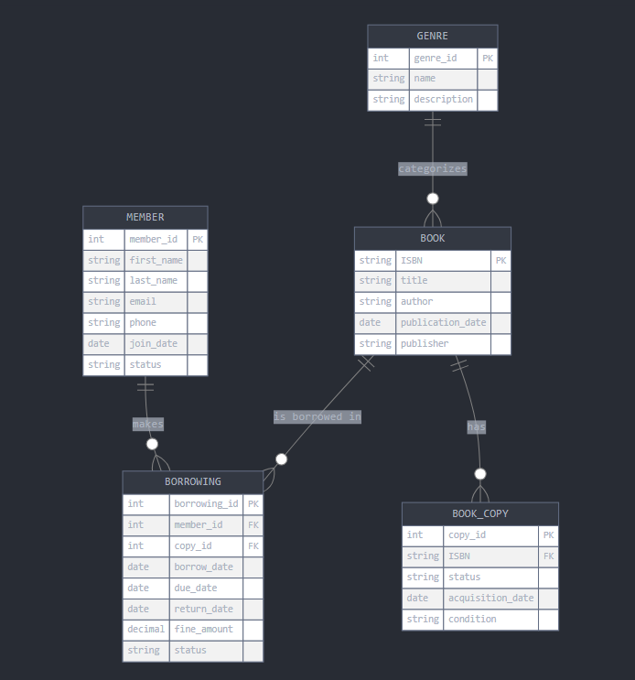erDiagram

BOOK ||--o{ BORROWING : "is borrowed in"

MEMBER ||--o{ BORROWING : "makes"

BOOK ||--o{ BOOK_COPY : "has"

GENRE ||--o{ BOOK : "categorizes"

BOOK {

string ISBN PK

string title

string author

date publication_date

string publisher

}

BOOK_COPY {

int copy_id PK

string ISBN FK

string status

date acquisition_date

string condition

}

MEMBER {

int member_id PK

string first_name

string last_name

string email

string phone

date join_date

string status

}

BORROWING {

int borrowing_id PK

int member_id FK

int copy_id FK

date borrow_date

date due_date

date return_date

decimal fine_amount

string status

}

GENRE {

int genre_id PK

string name

string description

}

```

Let me explain the entities and their relationships in detail:

1. BOOK Entity:

- Primary key: ISBN (unique identifier for each book)

- Contains basic book information like title, author, publication date

- Has a many-to-one relationship with GENRE

- One book can have multiple copies (one-to-many with BOOK_COPY)

2. BOOK_COPY Entity:

- Primary key: copy_id

- Represents individual physical copies of books

- Foreign key: ISBN (links to BOOK)

- Tracks status (available, borrowed, lost, etc.)

- Includes condition and acquisition date

3. MEMBER Entity:

- Primary key: member_id

- Stores member personal information

- Tracks membership status and join date

- Can make multiple borrowings (one-to-many with BORROWING)

4. BORROWING Entity:

- Primary key: borrowing_id

- Foreign keys: member_id and copy_id

- Records all borrowing transactions

- Tracks dates (borrow, due, return)

- Includes fine calculation and status

5. GENRE Entity:

- Primary key: genre_id

- Categorizes books

- One genre can be associated with multiple books

Key Relationships:

- A BOOK can have multiple BOOK_COPIES (1:N)

- A MEMBER can make multiple BORROWINGS (1:N)

- A BOOK_COPY can be involved in multiple BORROWINGS over time (1:N)

- A GENRE can categorize multiple BOOKS (1:N)

This design allows the library to:

- Track the status of individual book copies

- Maintain member borrowing history

- Calculate overdue fines

- Generate reports on book availability

- Manage member status and activities

Would you like me to explain any particular aspect of the design in more detail?

### What is Testing?

Testing in the context of software development is the process of evaluating and verifying that a software application or system meets the specified requirements. It involves executing the software with the intent of identifying any errors, bugs, or issues that could impact its functionality, performance, security, or user experience. The primary goal of testing is to ensure that the software is reliable and performs as expected in different scenarios.

### Validation vs. Verification

Although both validation and verification are essential parts of the software testing process, they serve different purposes and are performed at different stages. Here are the key differences between validation and verification:

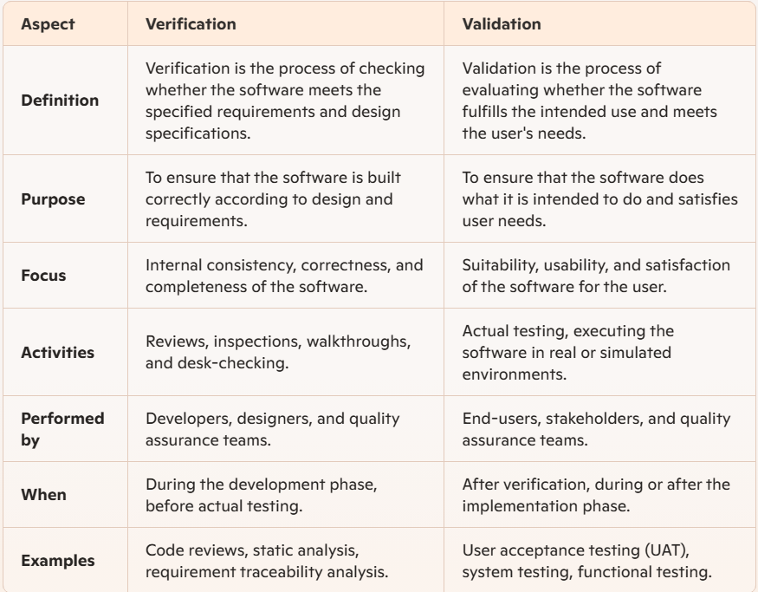

In summary:

**Verification** is about ensuring that the product is built correctly according to specifications and design documents.

**Validation** is about ensuring that the correct product is built and that it meets the user's needs and expectations.

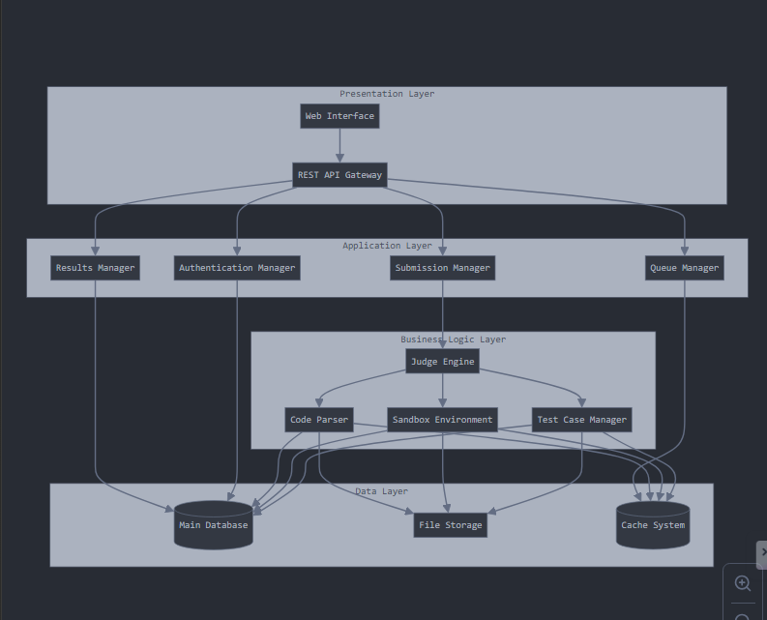

Let me explain each layer and its responsibilities in detail:

1. Presentation Layer

- Web Interface: Provides the user-facing frontend for problem solving, submissions, and results viewing

- REST API Gateway: Handles HTTP requests, input validation, and response formatting

- Responsibilities:

- User interface rendering and interaction

- Request/response handling

- Basic input validation

- Session management

2. Application Layer

- Authentication Manager: Handles user authentication and authorization

- Submission Manager: Processes incoming code submissions and manages submission workflow

- Queue Manager: Orchestrates the submission queue and load balancing

- Results Manager: Processes and formats judge results

- Responsibilities:

- Workflow orchestration

- Request processing

- State management

- Service coordination

3. Business Logic Layer

- Judge Engine: Core component that executes and evaluates submissions

- Test Case Manager: Handles test case storage, retrieval, and validation

- Sandbox Environment: Provides isolated execution environment for submitted code

- Code Parser: Analyzes and validates submitted code

- Responsibilities:

- Code execution

- Test case validation

- Security isolation

- Performance measurement

- Result evaluation

4. Data Layer

- Main Database: Stores user data, problems, submissions, and results

- File Storage: Manages test cases and submission files

- Cache System: Handles frequently accessed data and queue management

- Responsibilities:

- Data persistence

- File management

- Caching

- Data retrieval and storage optimization

This architecture ensures:

Scalability:

- Horizontal scaling through independent layer deployment

- Queue-based processing for handling high submission loads

- Caching layer for improved performance

- Stateless design in the application layer

Maintainability:

- Clear separation of concerns

- Modular component design

- Independent testing of each layer

- Easy to add new features or modify existing ones

- Simplified debugging and monitoring

Performance:

- Caching frequently accessed data

- Asynchronous processing of submissions

- Load balancing across judge instances

- Optimized database queries and indexes

Security:

- Isolated execution environment

- Input validation at multiple layers

- Authentication and authorization controls

- Secure file storage and access

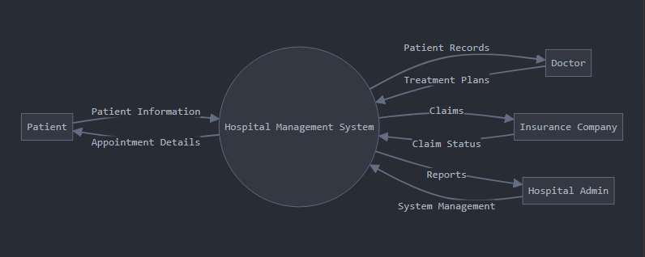

1. level dfd
2. Level-0 DFD (Context Diagram):

* Shows system boundaries
* External entities: Patient, Doctor, Insurance Company, Admin
* Basic information flows between entities and system

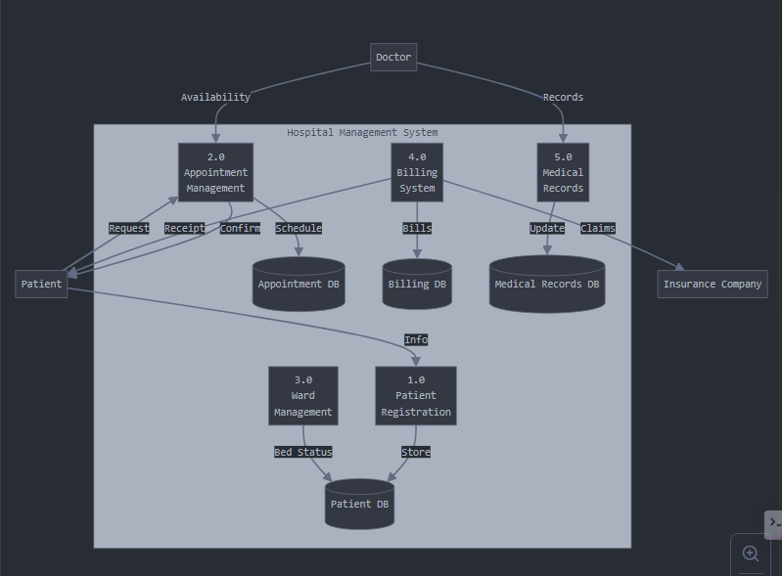

1. Level-1 DFD:

* Major Processes:
  + Patient Registration (1.0)
  + Appointment Management (2.0)
  + Ward Management (3.0)
  + Billing System (4.0)
  + Medical Records (5.0)
* Data Stores:
  + Patient Database
  + Appointment Database
  + Billing Database
  + Medical Records Database

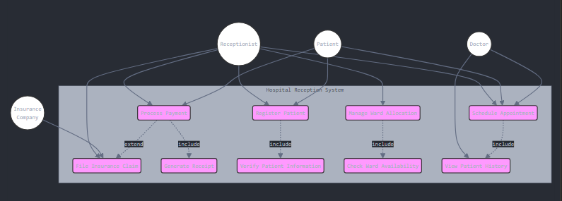

Key elements of this improved Use Case diagram:

1. Actors:
   1. Receptionist (primary actor)
   2. Patient
   3. Doctor
   4. Insurance Company
2. Main Use Cases:
   1. Register Patient
   2. Schedule Appointment
   3. Manage Ward Allocation
   4. Process Payment
   5. File Insurance Claim
   6. Generate Receipt
   7. View Patient History
3. Relationships:
   1. Include relationships (dotted arrows with <<include>>):
      1. Patient Registration includes Verify Patient Information
      2. Payment Processing includes Generate Receipt
      3. Ward Allocation includes Check Ward Availability
      4. Appointment Scheduling includes View Patient History
   2. Extend relationship (dotted arrow with <<extend>>):
      1. Process Payment extends to File Insurance Claim when needed
4. System Boundary:
   1. Clearly defined system boundary showing what's included in the Hospital Reception System

This diagram better represents:

* Clear actor responsibilities
* Proper UML notation for relationships
* Core vs. supporting use cases
* System scope and boundaries
* Dependencies between use cases

The Sequence Diagram includes three main classes—****LoginScreen****, ****ValidateUser****, and ****Database****—based on the interactions shown. The ****Student**** is typically treated as an external actor rather than a class in this context.

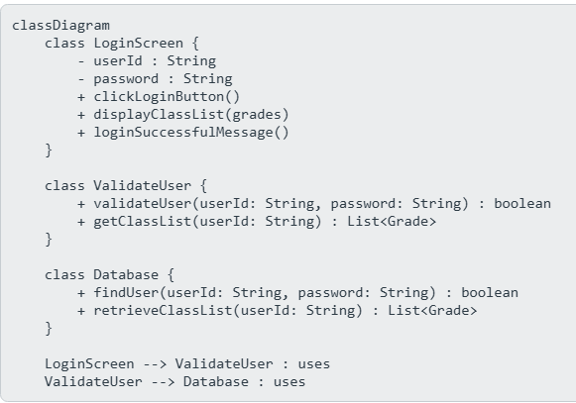

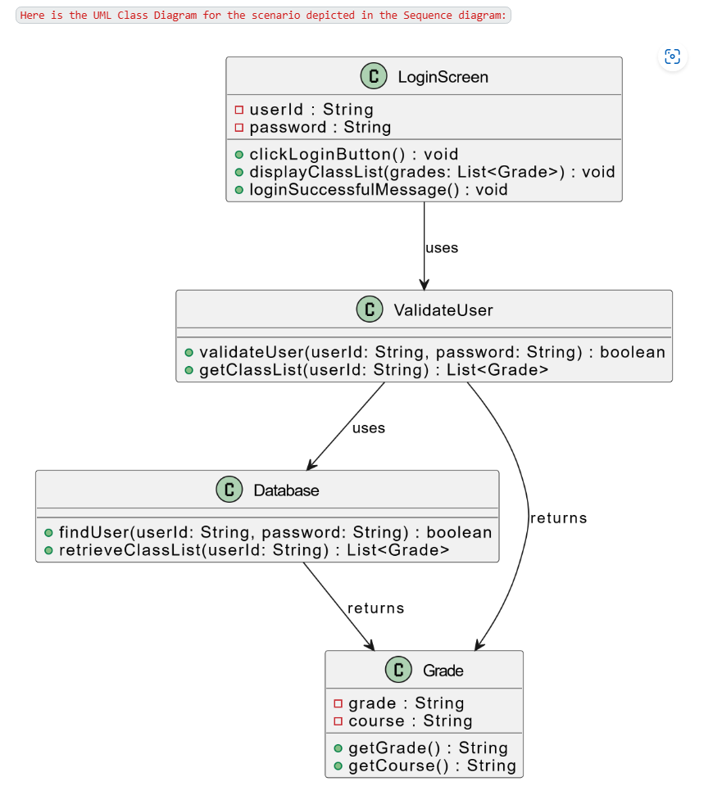

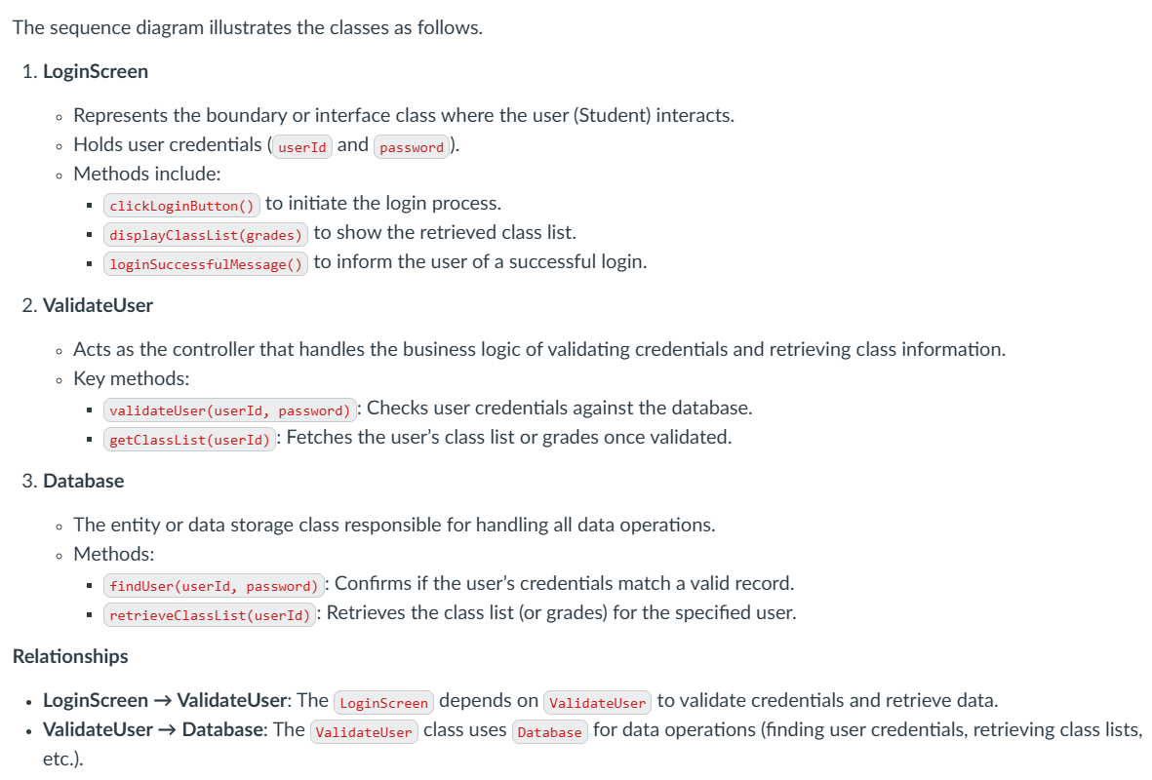

Absolutely, let's dive into the nitty-gritty of Quality Assurance (QA) and Quality Control (QC):

### Quality Assurance (QA)

- Definition: QA is a proactive process aimed at preventing defects in the development process by ensuring that the methods, techniques, and activities employed in a project are adequate for the task. It focuses on improving the process of development and making it efficient and effective as per the quality standards defined for software products.

- Process-Oriented: QA is concerned with the entire development process, ensuring that quality is built into the process from the beginning. It's about establishing and maintaining set processes, activities, and standards to prevent defects.

- Activities Involved: QA activities include process definition and implementation, training, audits, and continuous process improvement.

### Quality Control (QC)

- Definition: QC is a reactive process that focuses on identifying defects in the final product. It involves the activities that are designed to determine the level of quality of the delivered product and to identify areas where the product does not meet quality standards.

- Product-Oriented: QC is primarily about detecting defects in the final product and ensuring that the output meets the quality standards defined.

- Activities Involved: QC activities include inspection, testing, and peer reviews to ensure that the final product meets the required standards and specifications.

### Differences Between QA and QC

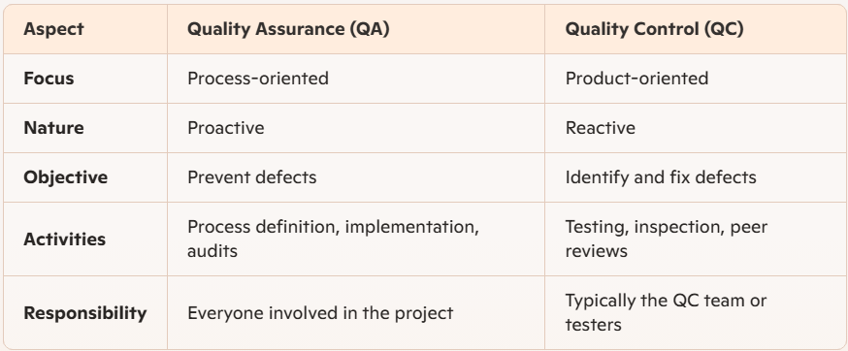

### Impediments to QA and QC

- Impediments to QA:

- Lack of Standards: Inadequate or poorly defined processes and standards can lead to ineffective QA practices.

- Resistance to Change: Resistance from team members in adopting new processes and standards can impede QA efforts.

- Insufficient Training: Lack of proper training for team members on quality standards and processes.

- Impediments to QC:

- Insufficient Time: Limited time allocated for thorough testing and inspection can lead to defects being missed.

- Incomplete Requirements: Lack of clear and complete requirements can make it challenging to validate the product against standards.

- Inadequate Tools: Lack of proper tools and resources for effective testing and inspection.

Both QA and QC are essential for delivering a high-quality product, and they complement each other by ensuring that quality is maintained throughout the development process and in the final product.

Absolutely, the goal of QA is not just about finding bugs early. While identifying and fixing defects early is crucial, the overarching objective of QA is to ensure that the entire development process adheres to standards that will prevent defects and enhance quality.

### Role of Quality Assurance (QA) at Each Phase of the Software Development Life Cycle (SDLC)

1. Planning Phase

- Role of QA: QA sets the stage by establishing standards, processes, and methodologies that will be followed throughout the project. This includes defining the quality objectives, criteria, and planning for quality assurance activities.

- Activities: QA creates the Quality Assurance Plan (QAP), which outlines the processes and metrics for ensuring quality. This may also include risk assessment and mitigation strategies.

2. Requirements Analysis Phase

- Role of QA: QA ensures that the requirements are clear, complete, and testable. It involves verifying that all stakeholders have a shared understanding of what the software needs to achieve.

- Activities: QA reviews requirements documents, conducts requirement traceability analysis, and participates in requirements reviews or walkthroughs.

3. Design Phase

- Role of QA: QA focuses on ensuring that the design meets the requirements and is built for quality. This includes ensuring that the design is scalable, efficient, and maintainable.

- Activities: QA reviews design documents, participates in design reviews, and ensures that the design adheres to standards and best practices. It may also involve creating a design validation plan.

4. Development (Implementation) Phase

- Role of QA: QA ensures that the code is being developed following the predefined standards and guidelines. It also ensures that unit testing and code reviews are conducted effectively.

- Activities: QA conducts code reviews, enforces coding standards, and ensures that developers perform unit testing and static code analysis.

5. Testing Phase

- Role of QA: QA oversees the entire testing process to ensure that the software meets the quality criteria and is defect-free. This phase is crucial for verifying that the software performs as expected.

- Activities: QA coordinates various testing activities, such as integration testing, system testing, regression testing, and acceptance testing. It also ensures that test cases are well-documented, and defects are tracked and resolved.

6. Deployment Phase

- Role of QA: QA ensures that the deployment process follows the predefined plan and that the software is correctly installed and configured in the production environment.

- Activities: QA verifies that deployment scripts are tested, performs installation verification, and ensures that post-deployment testing is conducted to confirm that the software functions correctly in the live environment.

7. Maintenance Phase

- Role of QA: QA ensures that any changes or updates to the software during maintenance do not negatively impact the existing functionality. This includes regression testing and ensuring adherence to change control processes.

- Activities: QA conducts impact analysis for any changes, ensures that regression tests are run, and verifies that bug fixes or updates are properly tested before release.

In summary, QA is integral to every phase of the SDLC, working proactively to ensure that quality is built into the process from start to finish, minimizing defects and enhancing the overall quality of the final product.

The Rapid Application Development (RAD) model is a software development methodology that emphasizes quick prototyping and iterative delivery, allowing for rapid user feedback and continuous refinement. This approach focuses on minimizing planning time and maximizing development speed, making it particularly effective for projects requiring swift adjustments to evolving requirements. 

**Key Phases of the RAD Model:**

1. **Requirements Planning:**
   1. **Description:** This initial phase involves collaborative discussions with stakeholders to outline the project's objectives and scope. The goal is to establish a clear vision without delving into detailed requirements.
   2. **Activities:** Conducting workshops, brainstorming sessions, and defining high-level project goals.
2. **User Design:**
   1. **Description:** In this phase, developers and users work together to create prototypes that represent desired features and functionalities. This collaborative effort ensures the system aligns with user expectations.
   2. **Activities:** Developing user interfaces, constructing data models, and designing system architectures through iterative prototyping.
3. **Construction:**
   1. **Description:** Building upon the prototypes, this phase involves the actual development of the application. Rapid construction is achieved by utilizing reusable components and continuous user feedback.
   2. **Activities:** Coding, system integration, and rigorous testing to ensure functionality aligns with user needs.
4. **Cutover:**
   1. **Description:** The final phase focuses on transitioning the completed application to the production environment. It encompasses final testing, user training, and system deployment.
   2. **Activities:** Performing acceptance testing, conducting user training sessions, and deploying the system for operational use.

**Principles of the RAD Model:**

* **User Involvement:** Continuous engagement with users throughout the development process ensures the final product meets their needs and expectations.
* **Iterative Development:** Frequent iterations and prototyping allow for regular feedback and refinements, accommodating changes efficiently.
* **Component-Based Construction:** Utilizing pre-built components accelerates development and enhances system reliability.
* **Flexibility in Requirements:** The RAD model welcomes evolving requirements, adapting to changes even during late stages of development.

**Advantages of the RAD Model:**

* **Faster Delivery:** The emphasis on prototyping and iterative development enables quicker delivery of functional software.
* **Enhanced User Satisfaction:** Active user participation ensures the final product aligns with user expectations, leading to higher satisfaction.
* **Reduced Development Risk:** Early and frequent testing identifies issues promptly, mitigating potential risks.
* **Flexibility and Adaptability:** The model's iterative nature allows for easy incorporation of changes, making it suitable for dynamic project environments.

**How the RAD Model Supports Faster Delivery While Maintaining Quality and User Satisfaction:**

The RAD model's iterative approach, combined with continuous user involvement, ensures that the development process remains aligned with user needs and expectations. By focusing on rapid prototyping, the model allows for early detection and correction of issues, maintaining high-quality standards. The use of reusable components not only speeds up development but also leverages existing, tested functionalities, further ensuring quality. This collaborative and flexible approach results in software solutions that are delivered swiftly without compromising on quality or user satisfaction.

In summary, the RAD model's focus on user collaboration, iterative prototyping, and flexibility makes it an effective methodology for developing high-quality software solutions rapidly, especially in environments where requirements are expected to evolve.

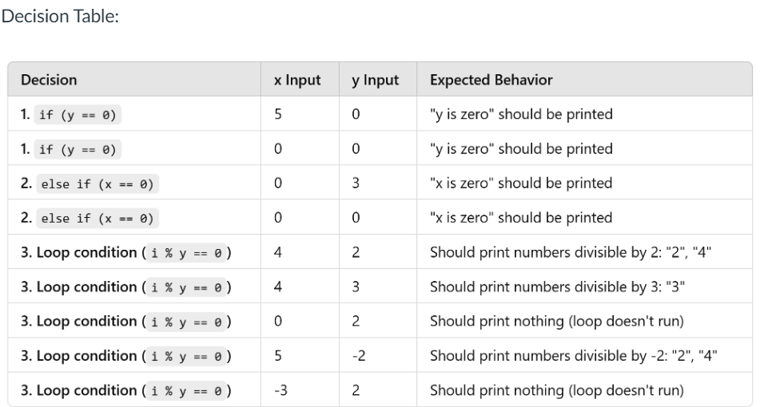

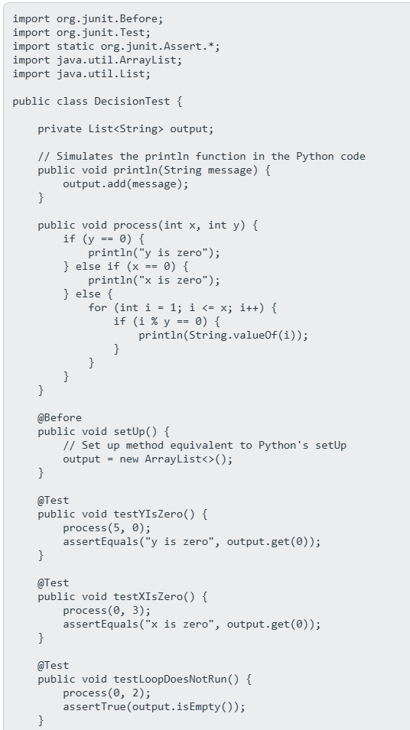

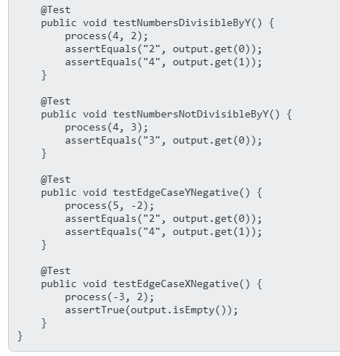

To develop JUnit 4 test codes for the production code using ****Exception handling****, ****Setup functions****, and ****Timeout rules****, you would apply the following:

#### 1. ****Exception Handling in Tests****:

@Test(expected = IllegalArgumentException.class)

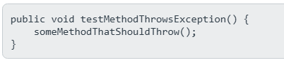

#### 2. ****Setup Function (Before)****:

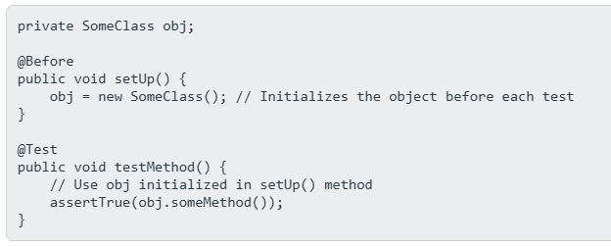

#### 3. ****Timeout Rule****:

@Rule

